Day-21:

1. File Management:

Write a script that takes a directory path as input and creates a new directory within it named "Backups_$(date +%Y-%m-%d)".

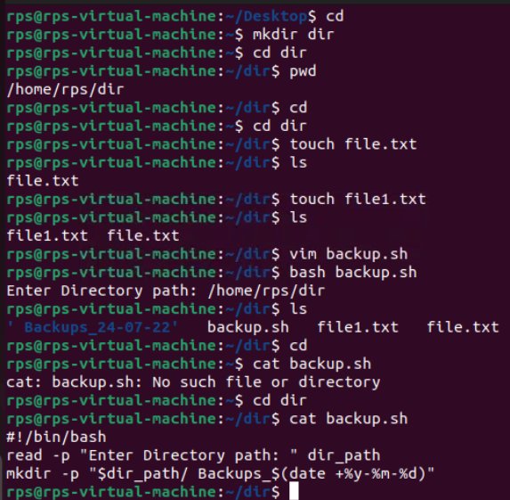

2. User Interaction:

Write a script that prompts the user for their name and age, then greets them with a personalized message**.**

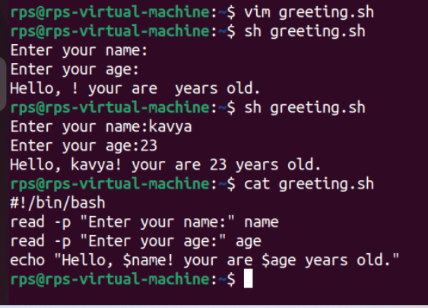

Design a script that displays a menu with options like "List files," "Create directory," and "Exit." Allow the user to choose an option and perform the corresponding action.

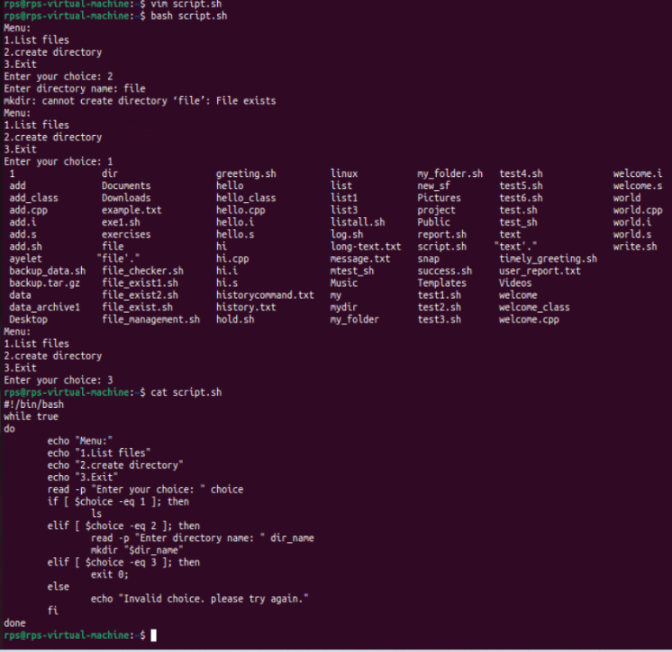

3. Text Processing:

Write a script that reads the contents of a file line by line, counts the number of lines, and prints the total.

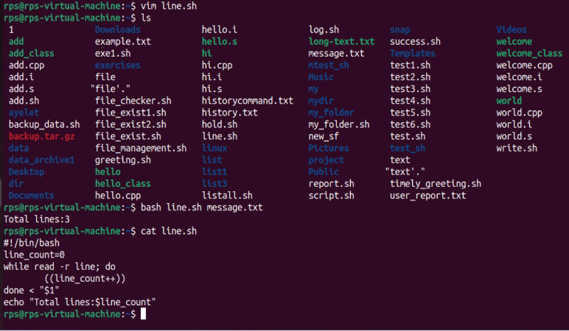

**Create a script that takes a text file as input and replaces all occurrences of a specific word with another word.**

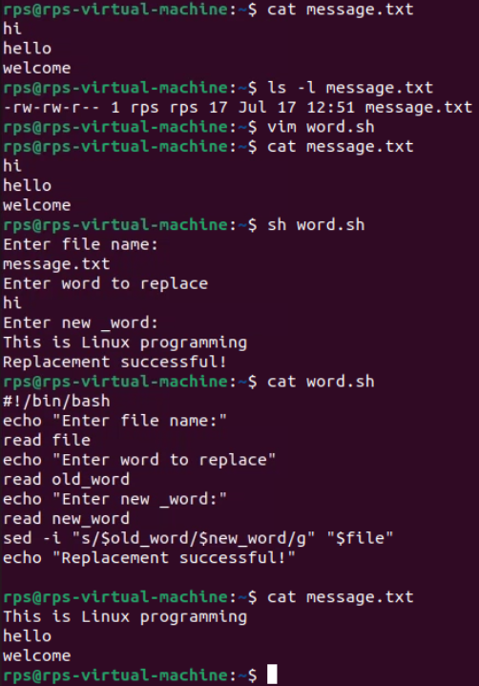

4. System Administration:

Write a script that checks if a specific package is installed and, if not, installs it using the appropriate package manager (e.g., apt-get, yum).

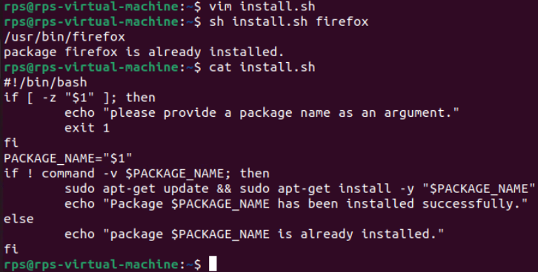

Create a script that monitors disk usage and sends an email notification if it exceeds a certain threshold**.**

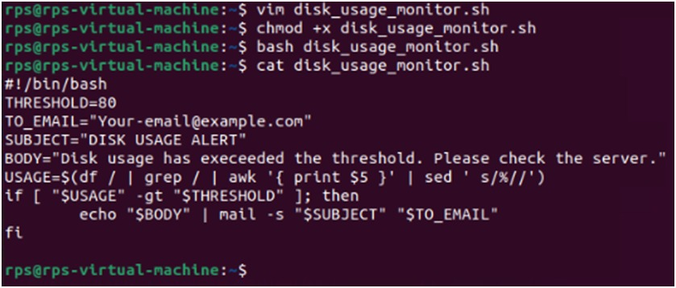

5. Network Operations:

Write a script that pings a list of servers and reports if any are unreachable.

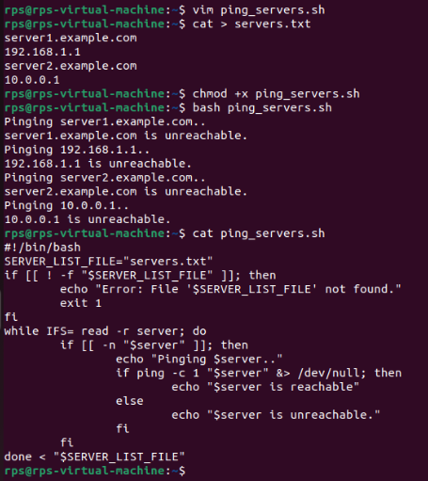

**Signals:**

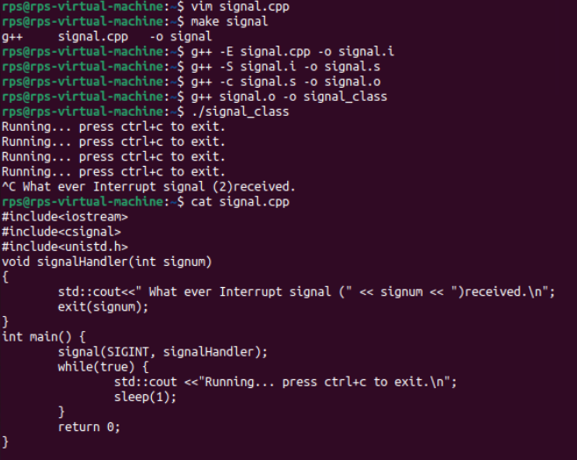

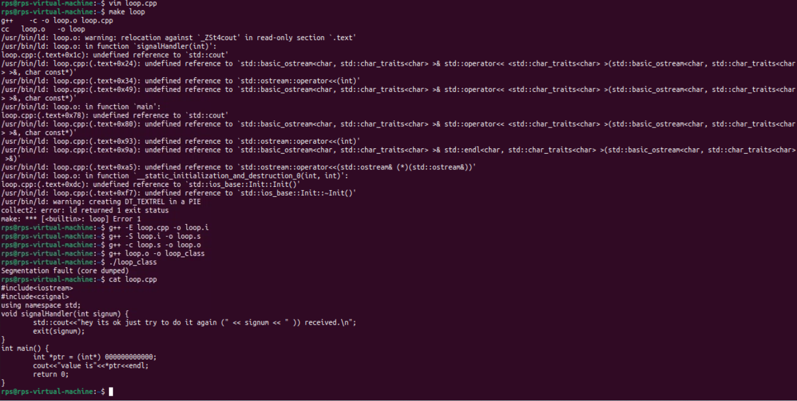

**Using kill SIGINT**

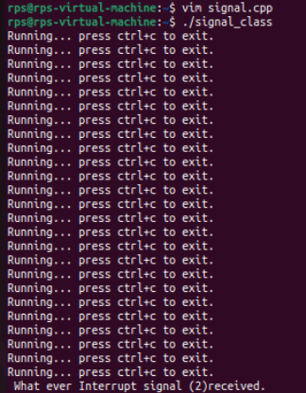

**USING KILL SIGSEGV**

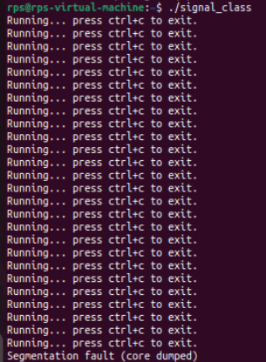

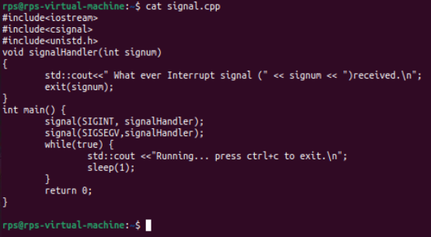

**Using ctrl+c and ctrl+z:**

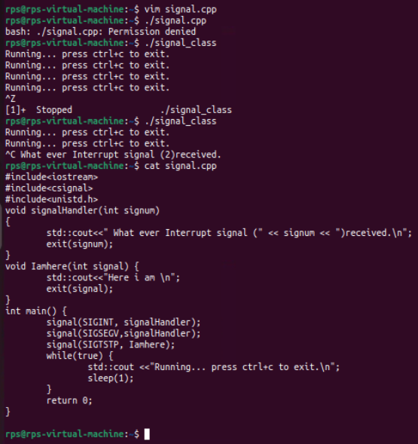

**Sigaction:**

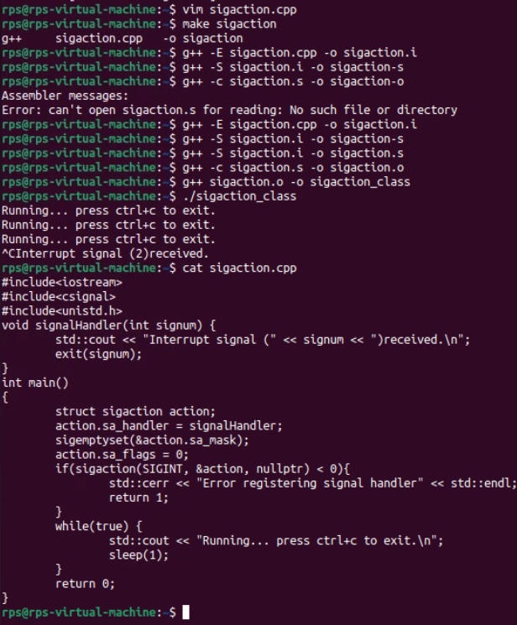

**Signum:**

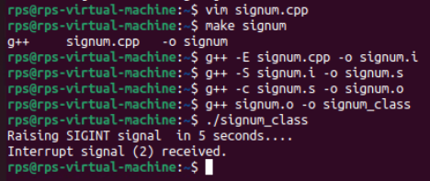

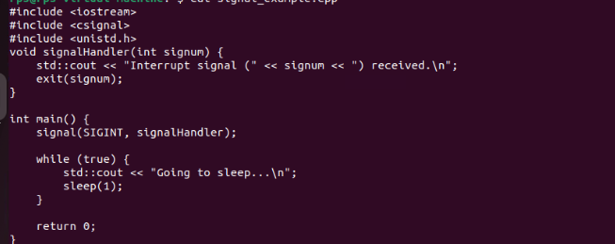

Basic Handling vs. Advanced Control: Implement signal handling using both signal and sigaction (in separate program runs). Observe the behavior. Which API allows for more control over the signal handler? Explain the key difference in a comment within your code.



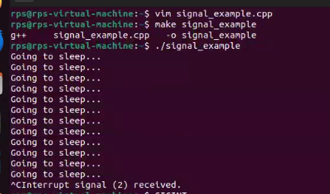

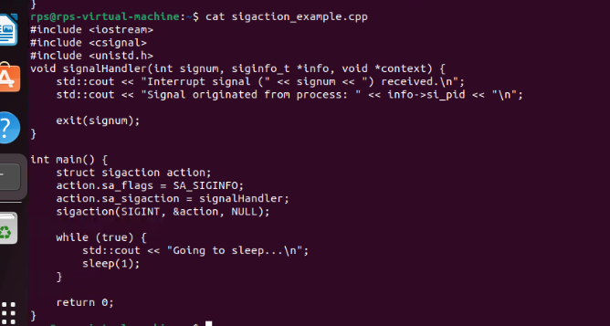

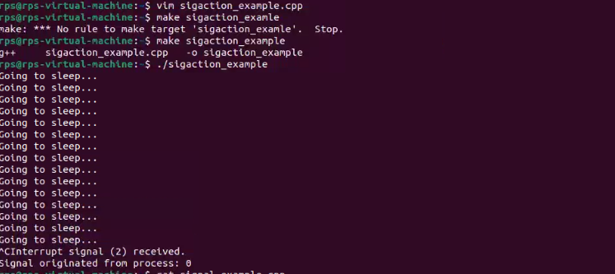

Objective: Modify your program to demonstrate graceful termination upon receiving a specific signal (e.g., SIGINT). Within the signal handler, perform any necessary cleanup tasks (e.g., closing files, releasing resources) before exiting the program gracefully.

Implementation:

In your signal handler function, include code to perform cleanup actions. This might involve closing open files, releasing memory, or writing data to disk.

Use exit(0) or similar methods to terminate the program after cleanup is complete.

